CAPTCHA



In this project you will make a project that can solve CAPTCHAs.

A “CAPTCHA” is a test used to recognise if a user is a human or a bot.

The aim of a CAPTCHA is to give the user something to do that is very easy for a human to do, but difficult for a computer to do.

Computers are getting better at solving CAPTCHAs all the time. In this project, you will try to create a computer program that can solve simple CAPTCHA challenges.

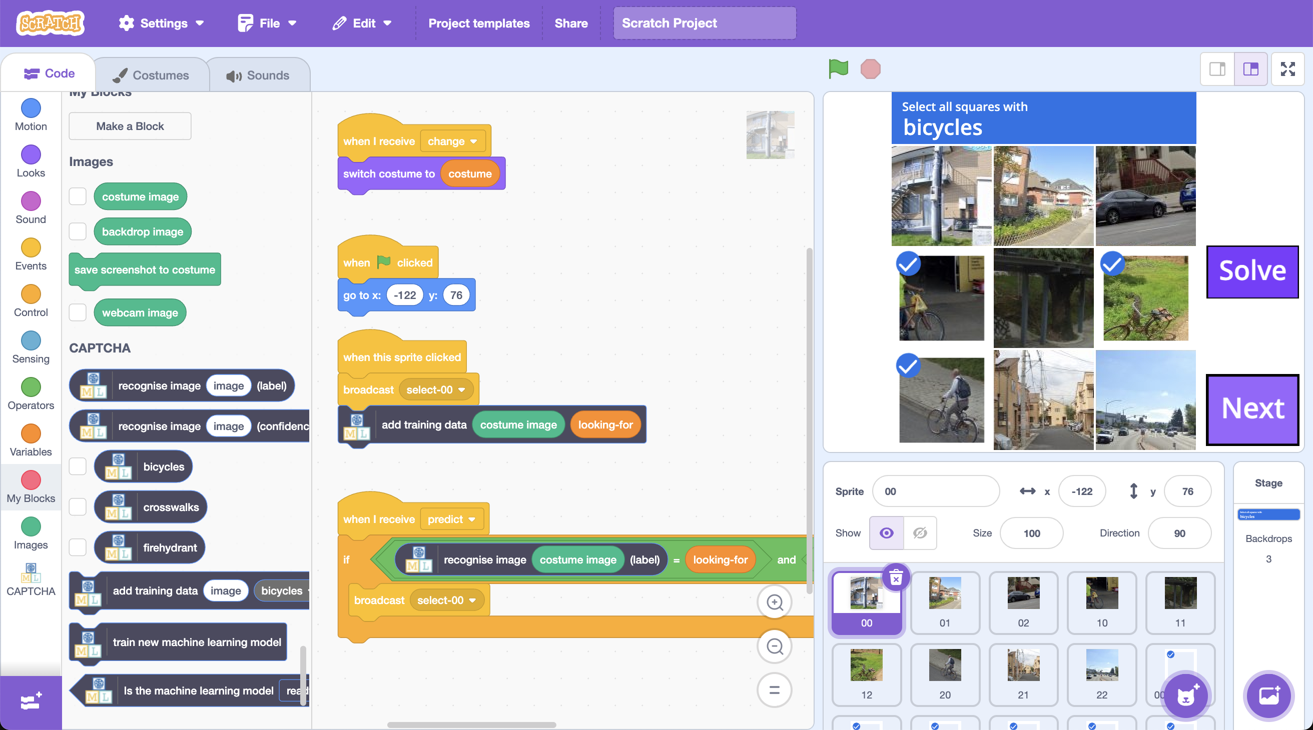

This project worksheet is licensed under a Creative Commons Attribution Non-Commercial Share-Alike License

http://creativecommons.org/licenses/by-nc-sa/4.0/

1. Go to <https://machinelearningforkids.co.uk/> in a web browser
2. Click on “**Get started**”
3. Click on “**Try it now**”
4. Click on “**Projects**” on the top menu bar
5. Click the **“Copy template**” button.
6. Find the “CAPTCHA” template and click on “**Import**”
7. Click on the “**Store on your computer**” button
8. You should see “**CAPTCHA**” in the list of your projects. Click on it.  
   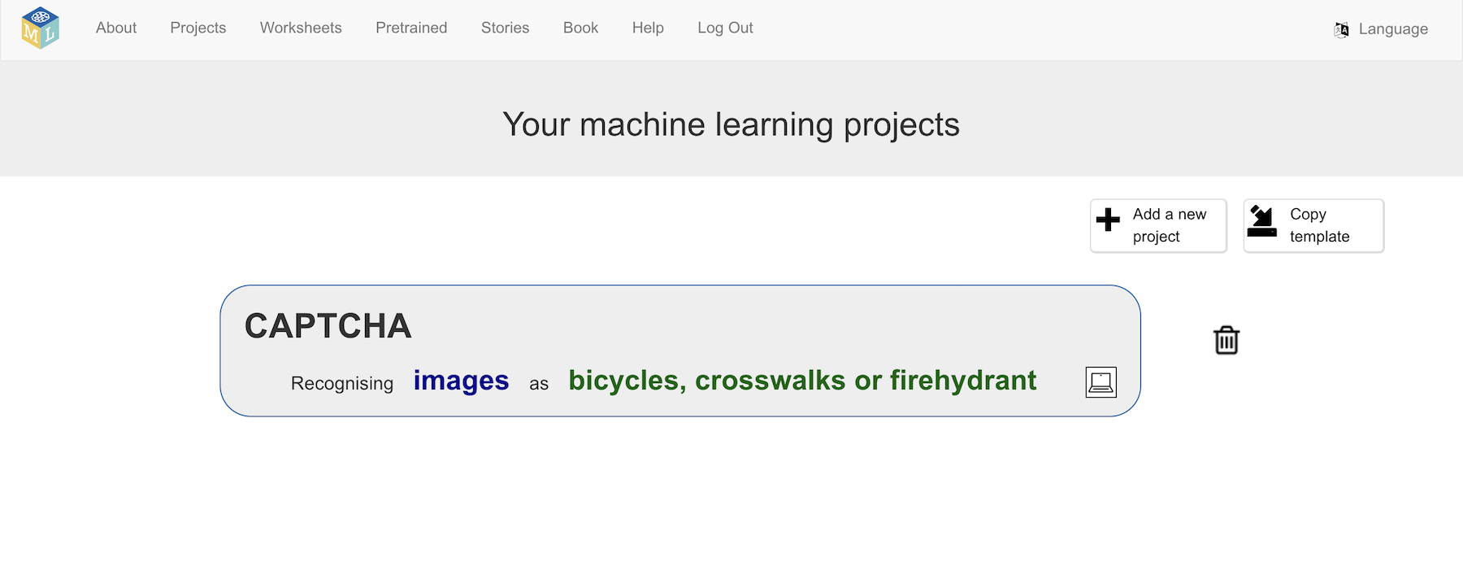
9. Start by reviewing the training buckets in the template. Click “**Train**”  
   *You will be training the computer to recognise CAPTCHAs of bicycles, crosswalks, and fire hydrants.*  
   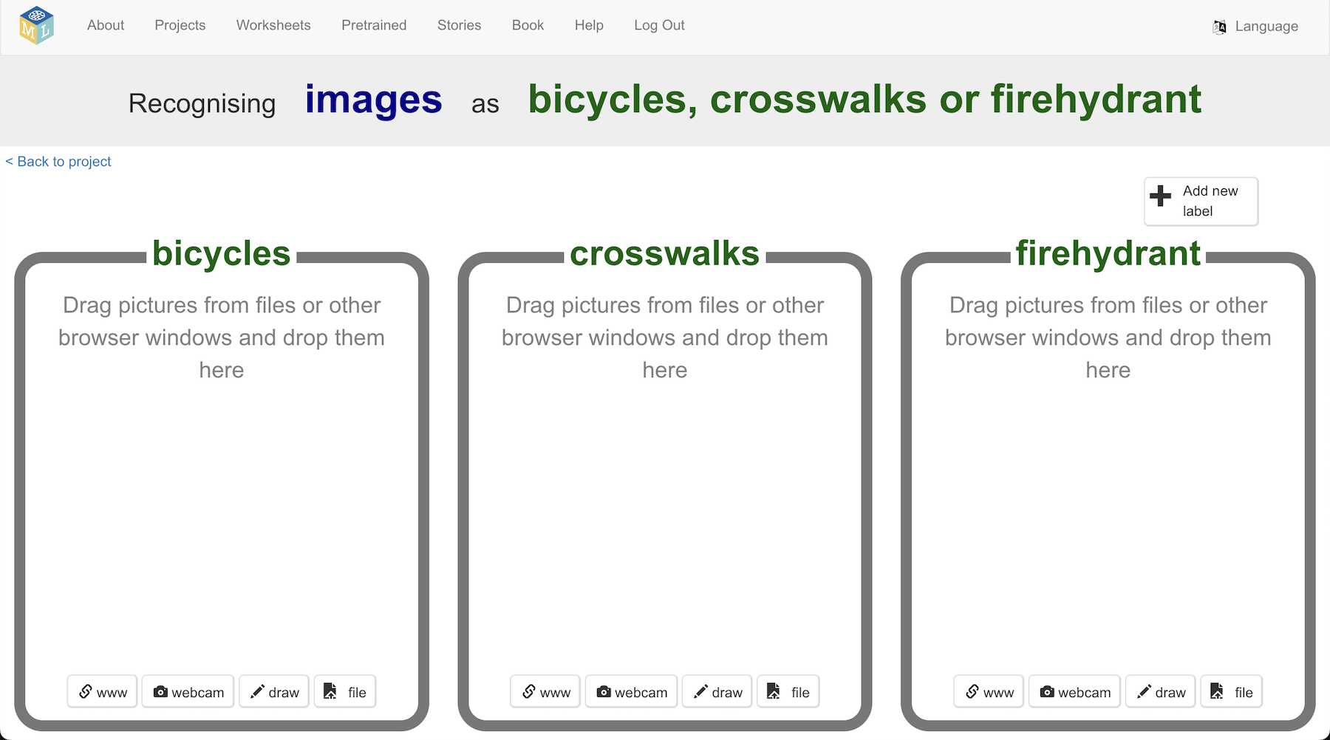
10. Click on “**< Back to project**”
11. Click on “**Make**”
12. Click the “**Scratch 3**” button
13. Click “**straight into Scratch**”  
    *The page will warn you that you haven’t trained a model yet, but that is okay as you will be using Scratch to collect your training data.*
14. In the Scratch window, click on “**Project templates**”
15. Click on the “**CAPTCHA**” template  
    *This is a very large template, as it contains many images.   
    Wait for the project to download.   
    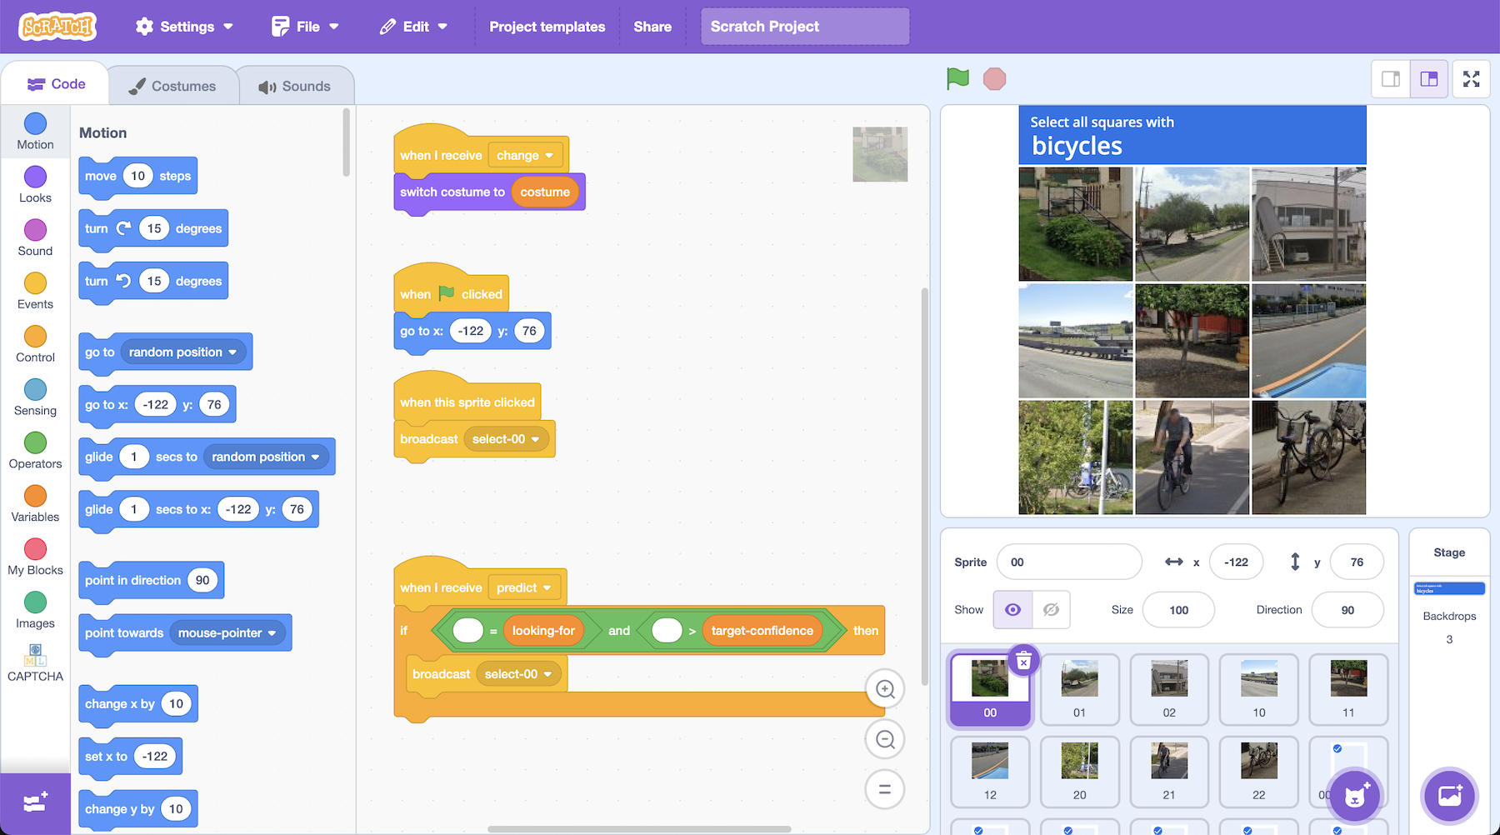*
16. Click on the **full-screen** button, and then click on the **Green Flag****
17. Try out a couple of CAPTCHA’s   
    *Click on the squares that you think match the prompt.   
    Click on the* ***Next*** *button to try another CAPTCHA  
    The next step is to start collecting images you can use to train the computer.*
18. Click on the **00** sprite and find the “**when this sprite clicked**” code  
    **
19. Update the code so that it looks like this   
    *When you click on the sprite, this will add the image to the training data*    
    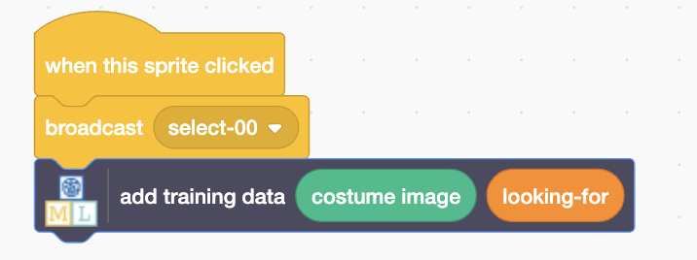
20. Click on the **01** sprite. Make the same change to the code.  
    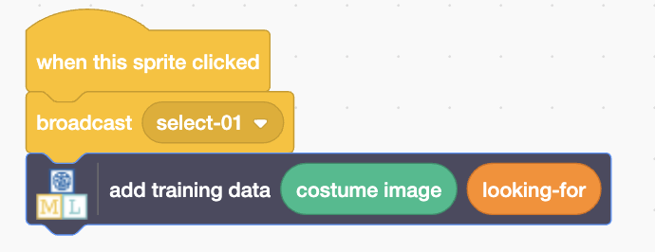
21. Repeat for the remaining grid sprites: **02**, **10**, **11**, **12**, **20**, **21**, **22**
22. Click on the full-screen button and Green Flag again  
    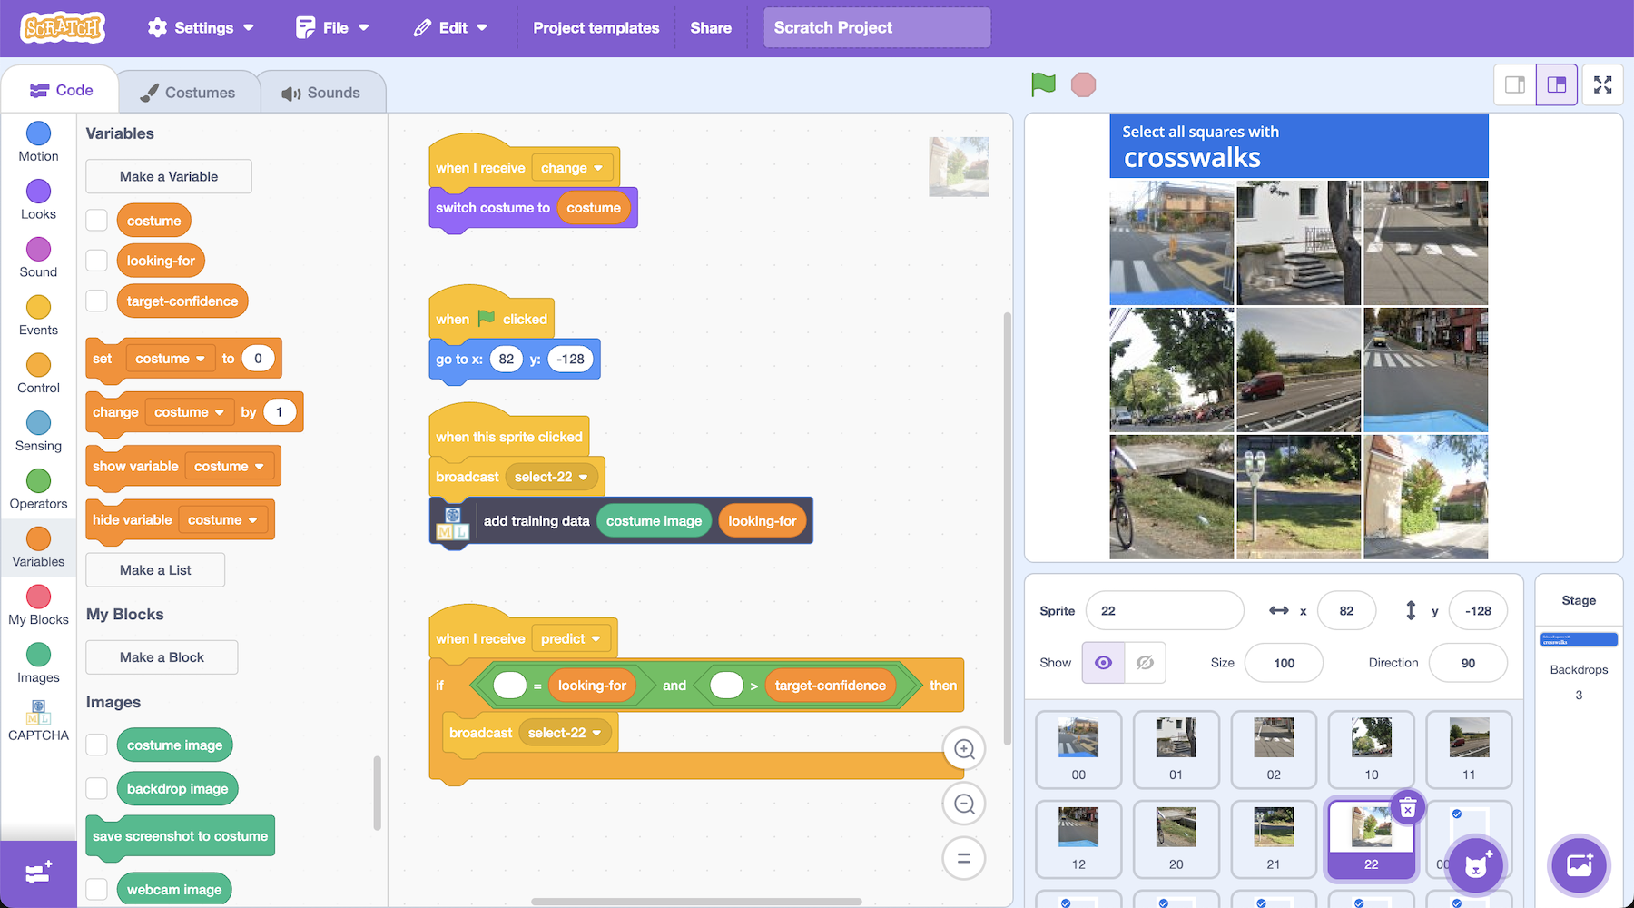
23. Complete **ten** CAPTCHA challenges
24. In the training tool tab, review the training data you collected  
    *Click on “****< Back to project****” and then click on “****Train****” to get to this page*  
    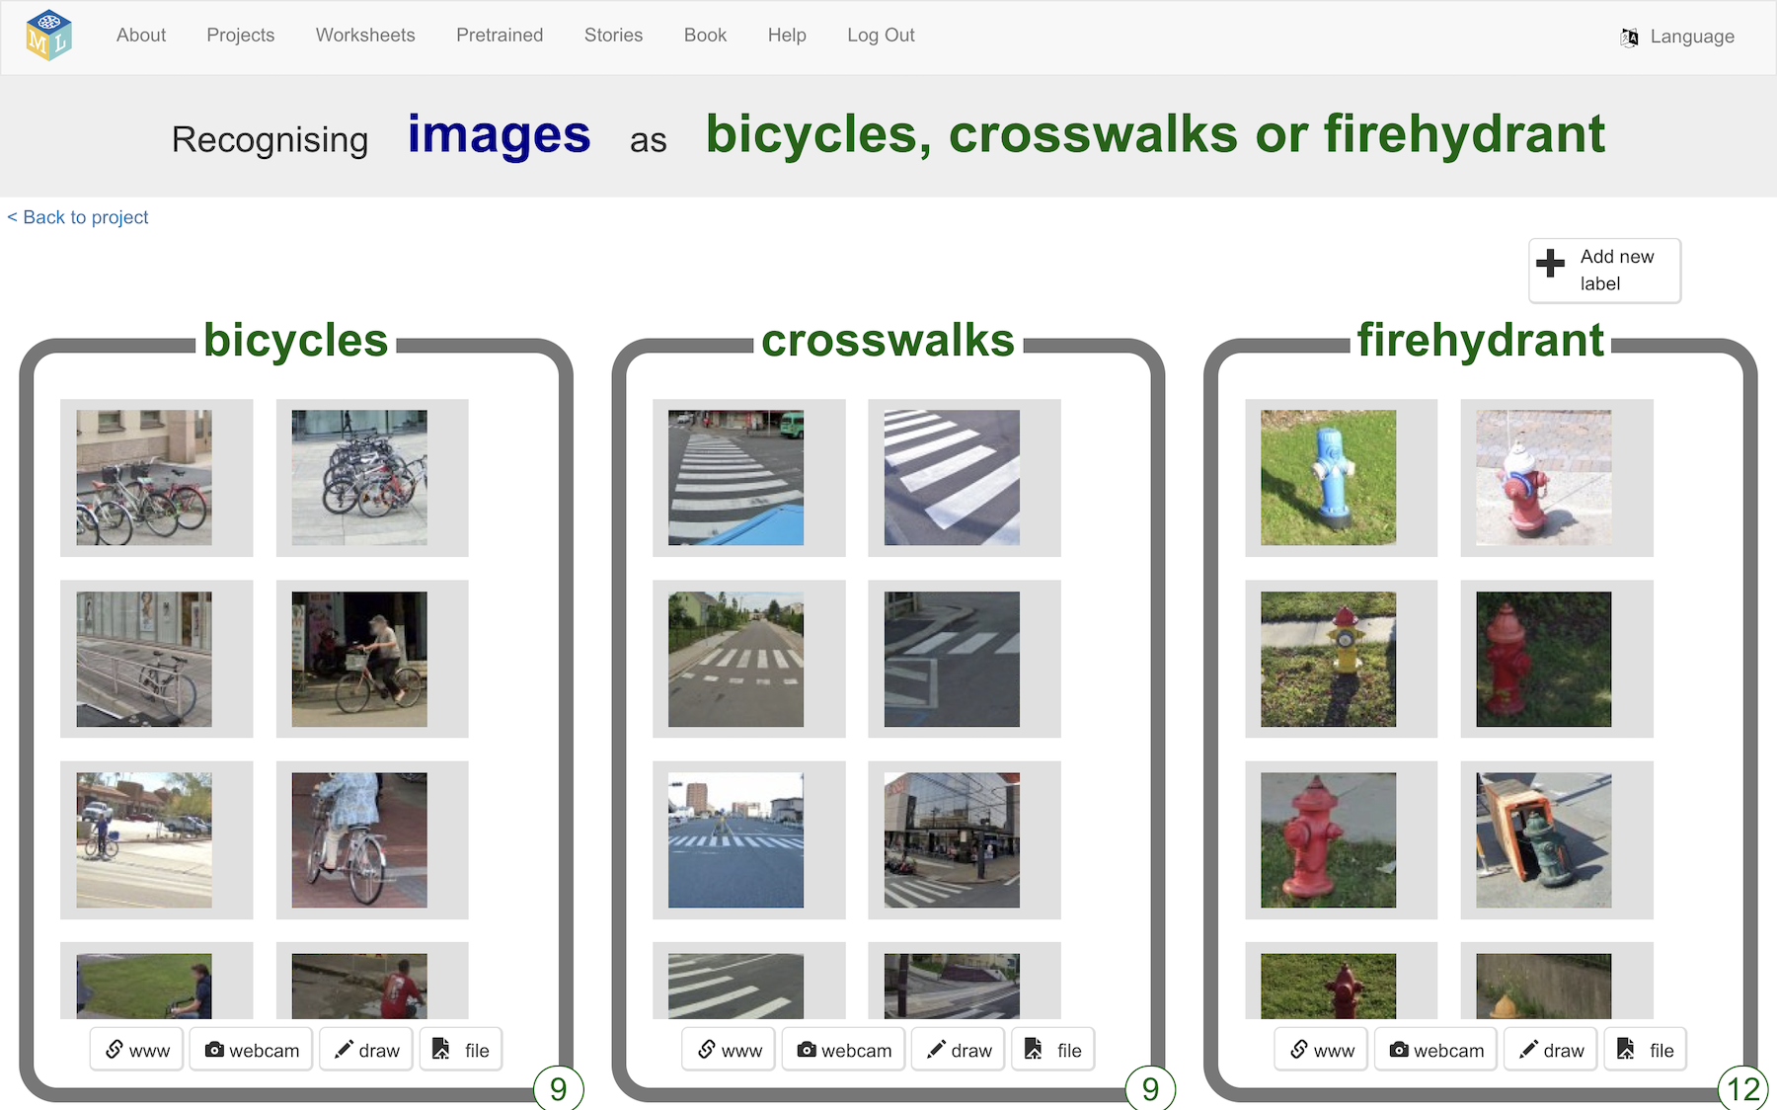
25. Click on “**< Back to project**”
26. Click on “**Learn & Test**”
27. Click on the “**Train new machine learning model**” button  
    *If the button is not there, you will need to complete another CAPTCHA first*

**What have you done so far?**

You’ve started to train a computer to recognise images from CAPTCHA challenges. You are doing it by collecting examples. These examples are being used to train a machine learning “model”.

This is called “supervised learning” because of the way you are supervising the computer’s training.

The computer will learn from patterns in the examples you’ve given it, such as colours, shapes and patterns. These will be used to be able to recognise new CAPTCHA images.

The next step is to modify your Scratch project to use the model to attempt to solve new CAPTCHAs.

1. In the Scratch tab, click on the **00** sprite.   
   Find the “**when I receive predict**” code.  
   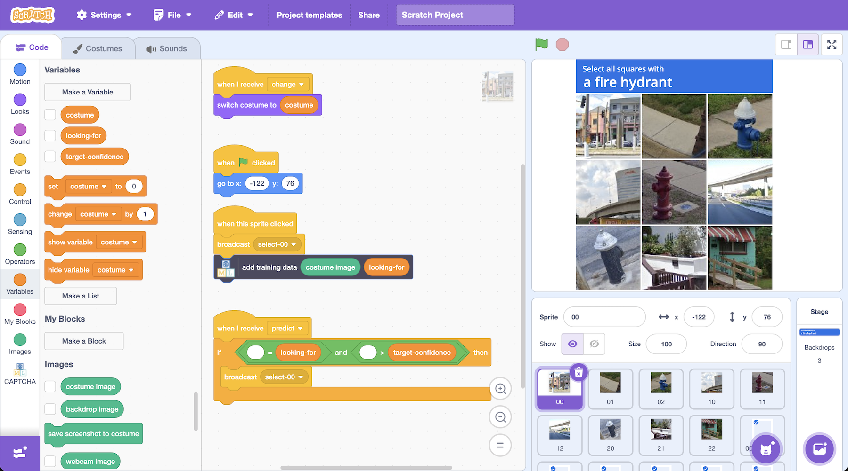
2. Update the code so that it looks like this:  
   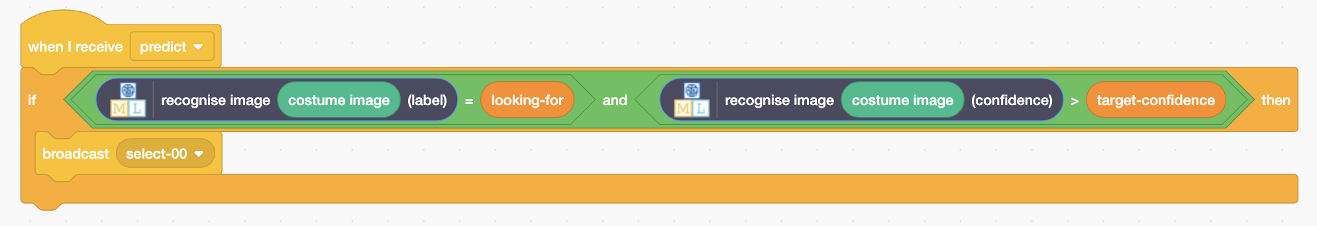
3. Click on the **01** sprite. Make the same change to the code.  
   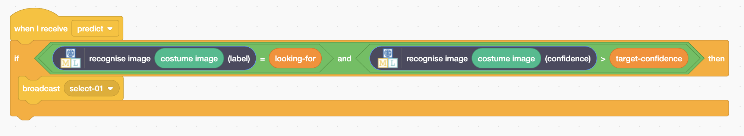
4. Click on the **02** sprite. Make the same change to the code.  
   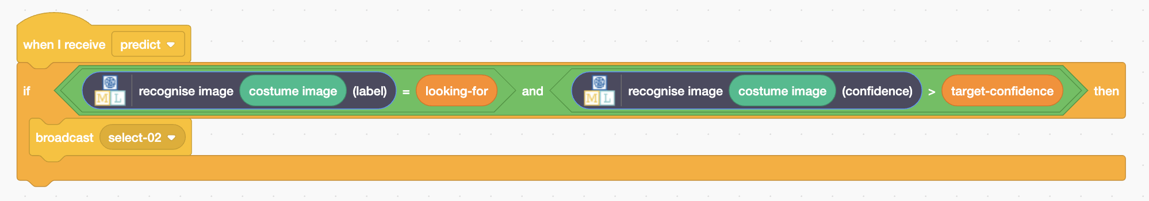
5. Repeat for the remaining grid sprites: **10**, **11**, **12**, **20**, **21**, **22**
6. Click on the “**predict**” sprite and find the Green Flag code  
   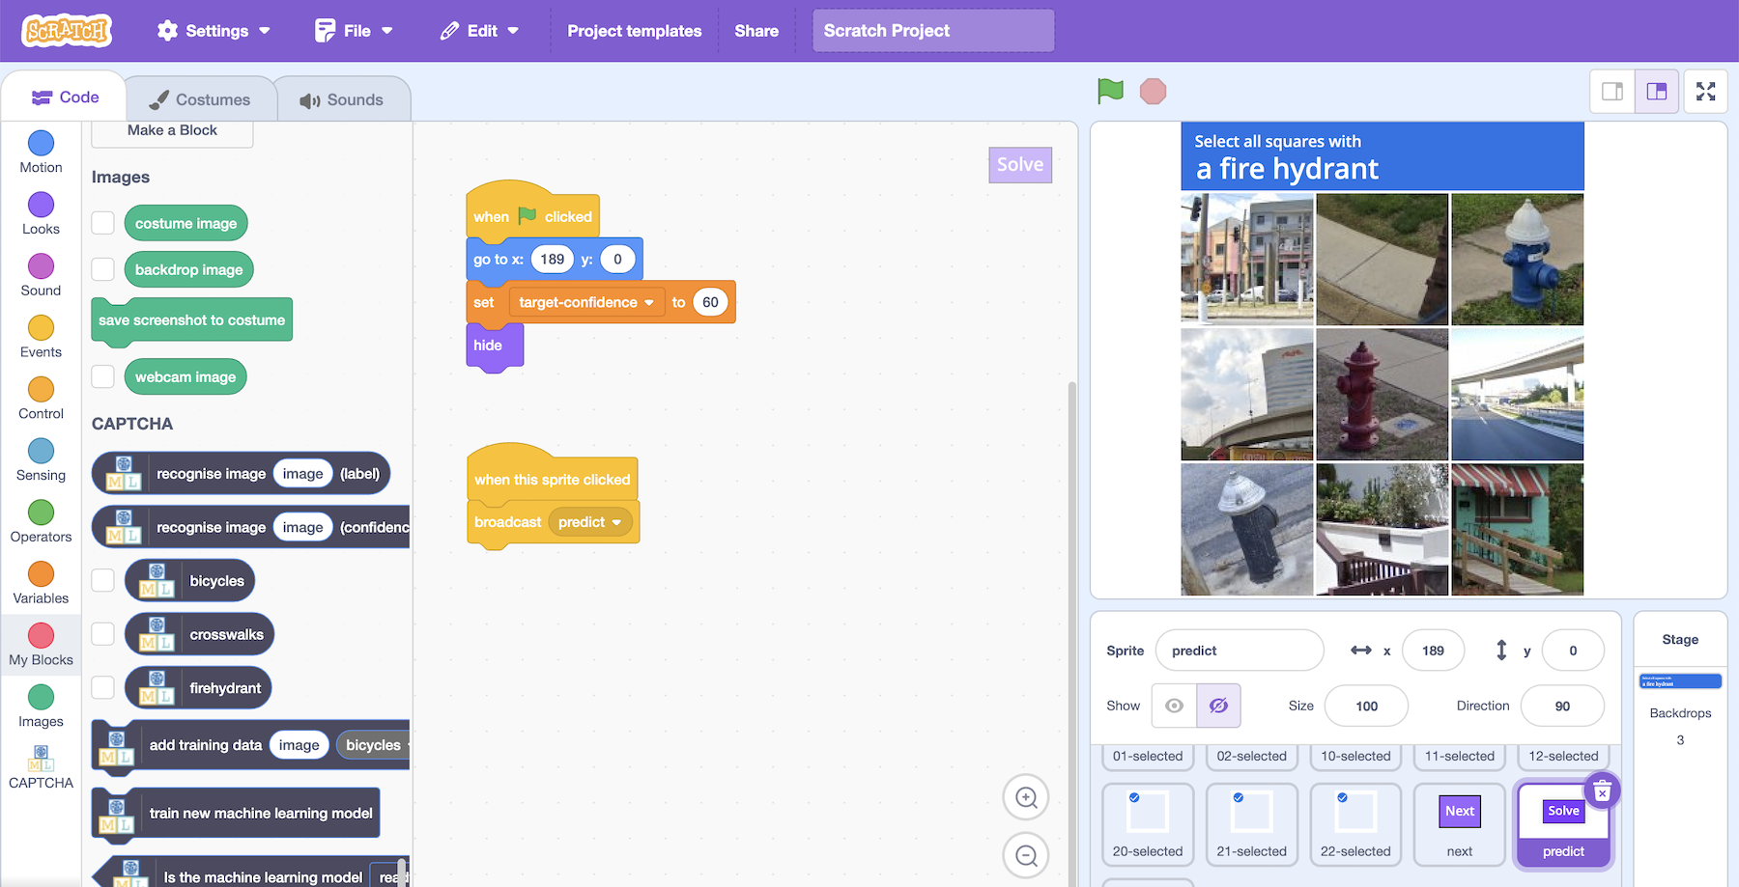
7. Replace the “**hide**” block with a “**show**” block  
   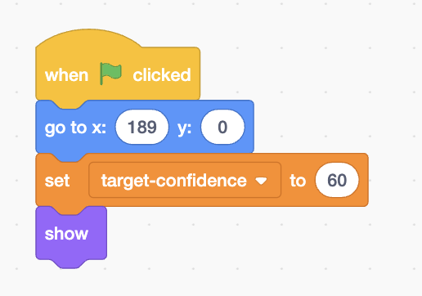
8. Click on the **full-screen** button and then the **Green Flag**
9. Click on the “**Solve**” button in the project and your machine learning model will select the grid squares that it predicts are a match  
   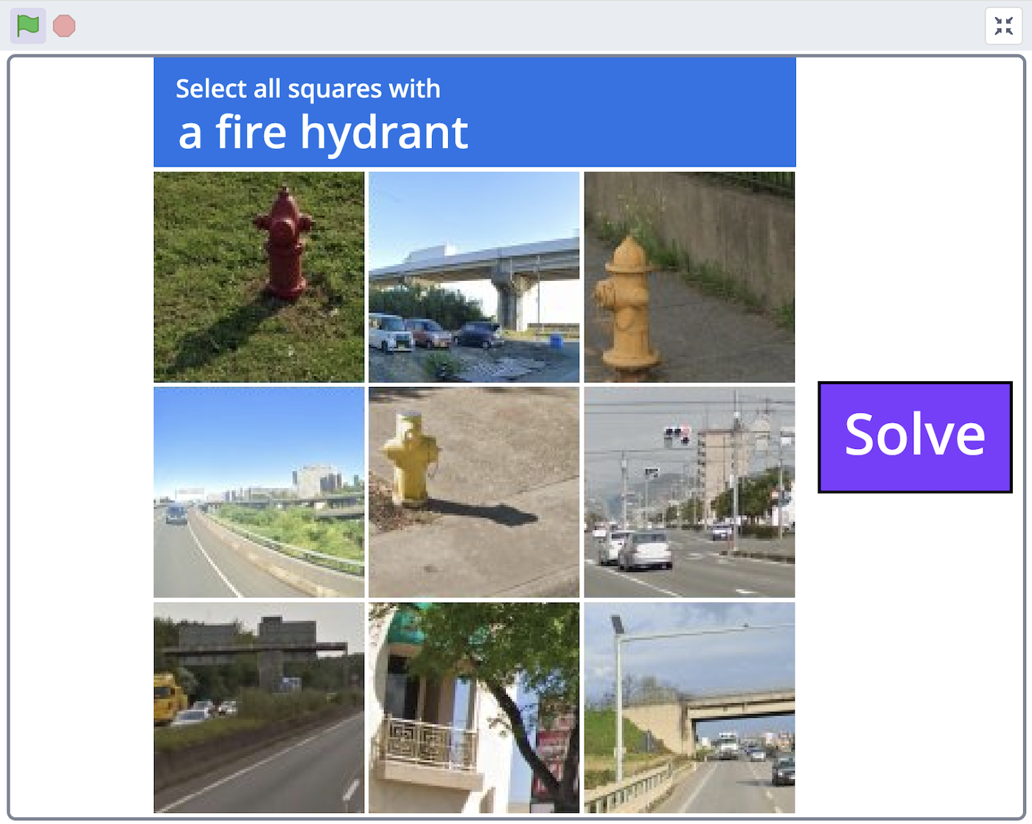
10. Click “**Next**” to get the next CAPTCHA challenge.   
    Click “**Solve**” again to test your model.
11. How good is your machine learning model at solving CAPTCHAs?  
    *With only a small number of examples to learn from, it will likely be making several mistakes.*   
    *More training examples should help.*
12. Try solving **ten** more CAPTCHA challenges yourself, without clicking on “**Solve**”, to add to your training examples.
13. Review the extra training examples in the “**Train**” page.
14. Go to the “**Learn & Test**” page.
15. Click on the “**Train new machine learning model**” button again to train a new model with the additional training examples
16. In the Scratch window, try using the “**Solve**” button to solve more CAPTCHA challenges.   
    *Have the additional training examples improved the model?*
17. Click on the “**predict**” sprite.   
    Increase the “target-confidence” value to **90**.  
    *This means your model will only select a grid square when it is at least 90% confident that it contains a match.*   
    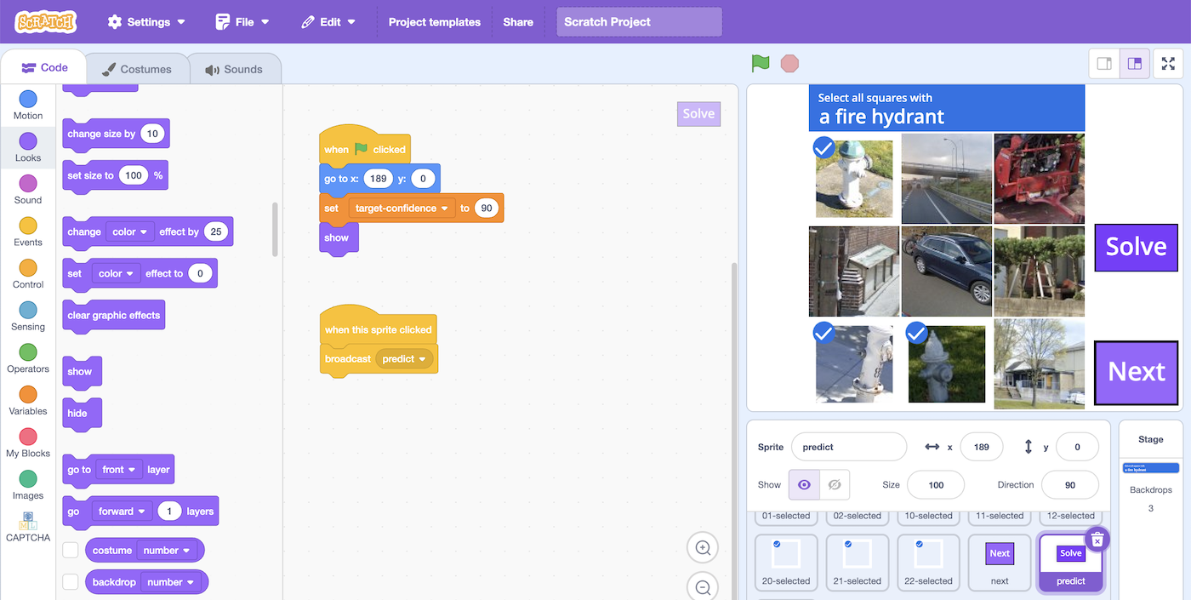
18. In the Scratch window, use the “**Solve**” button to solve more CAPTCHA challenges.   
    *Does the increased confidence score mean it makes fewer mistakes?*

**What have you done?**

You’ve explored ways to change how a machine learning project behaves.

Increasing the number of training examples is often a good way to improve the performance of a machine learning model.

Increasing the confidence threshold often reduces the number of incorrect selections the model makes, but may also prevent the model from making some correct selections.

**Ideas and Extensions**

Now that you’ve finished, why not give one of these ideas a try?

Or come up with one of your own?

**Write a reply**

Instead of just changing the way they look, make your character reply, based on what it recognises in the message!

**Try a different character**

Instead of a person’s face, why not try something different, like an animal?

It could react in different ways, instead of smiling.

For example, you could make a dog that wags their tail if you say something kind to it!

**Different emotions**

Instead of kind and mean, could you train the character to recognise other types of message?

**Real world sentiment analysis**

Can you think of examples where it’s useful to be able to train a computer to recognise the emotion in writing?